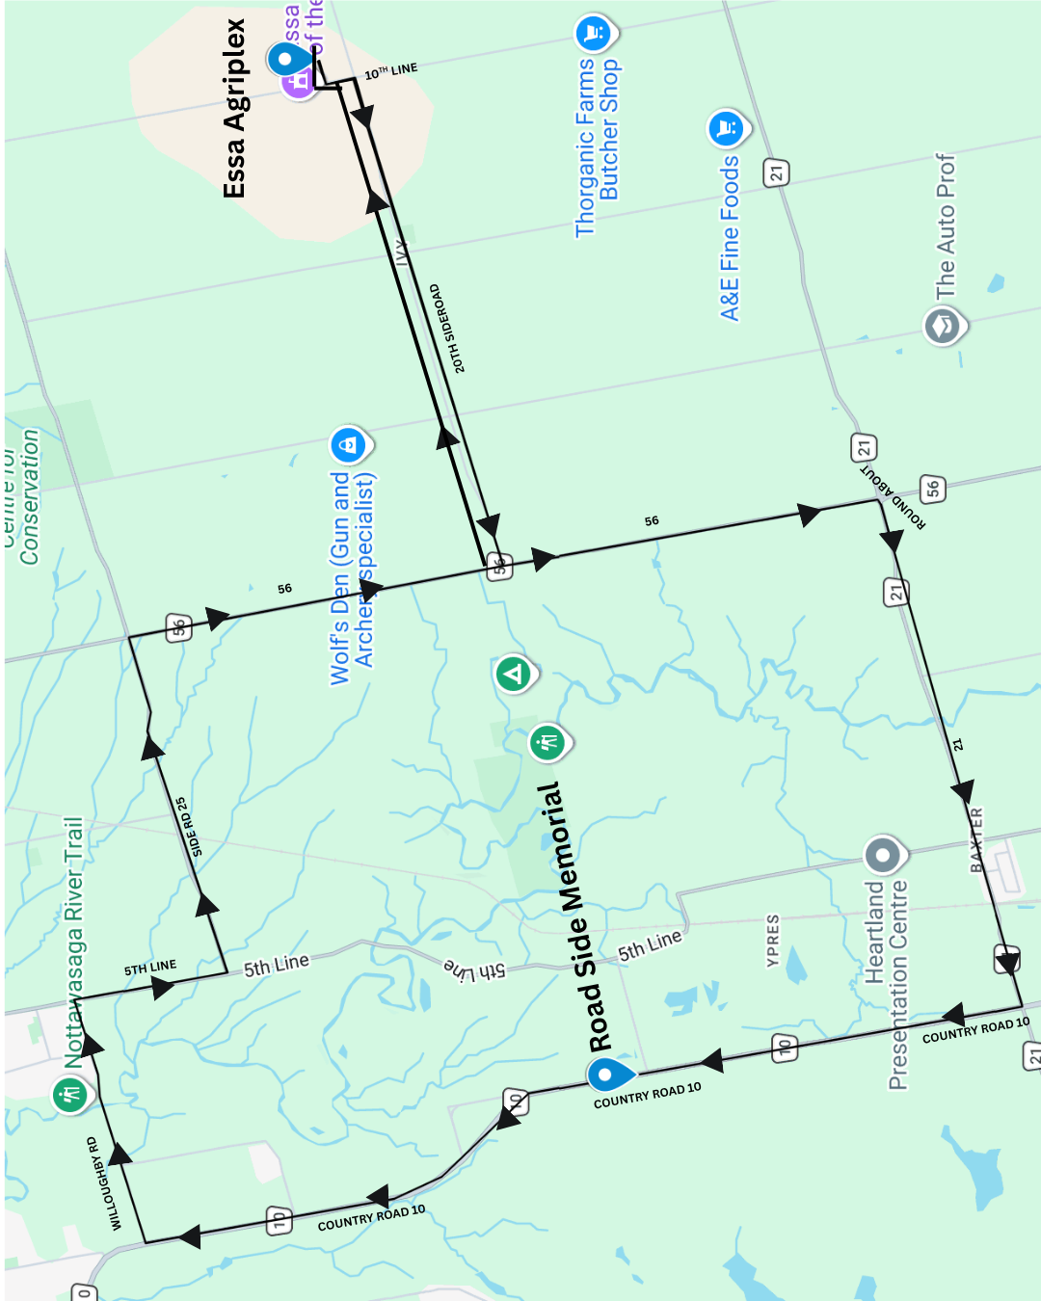

TURN BY TURN DIRECTIONS
- Start: Essa Arigplex First Gate. Entering on to the 10th Line
- Turning right onto the 20th Side Road.
- Left onto Country Road 56
- First exit at the roundabout (towards Baxter).
- Continue on Country Road 21 through Baxter.
- Right on Country Road 10, passing the road side memorial site that is on your left. (3km)
- Right onto Willoughby Road.
- Right onto the 5th Line. Left on the 25th Side Road.
- Make a right back onto Country Road 56.
- Left onto the 20th Side Road.
- Left at the 10th Line, returning back to the Essa Arigplex.

